Date of submission: 18-03-25
Batch: C3 Roll No.: 16010123217
Div: C
Student Name: Om Thanage
Experiment No: 6
Staff In-charge:

TITLE: Demonstrate the use of Cookies and Sessions in PHP.

AIM: To Understand the Difference between cookies & sessions.
To Understand how to create & destroy session /Cookies variables.
______________________________________________________________________
Expected Outcome of Experiment:
The expected outcomes aim to understand the differences between cookies and session with respect to storage, persistence, data accessibility, scope and security.

Books/ Journals/ Websites referred:

Steve Prettyman ,“Learn PHP 8 Using MySQL, JavaScript, CSS3, and HTML5”, Apress 2nd / 2020 edition.
____________________________________________________________________

- Problem Statement: Design and implement an application to demonstrate HTML form integration with PHP script for experiment 1 to
1. Create, modify with timer and delete cookies for a user.
a. A cookie is created with the setcookie( ) function.
Syntax: setcookie(name, value, expire, path, domain, secure, httponly);
bool setcookie (string $name [, string $value [, int $expire = 0 [, string $path [, string $domain [, bool $secure = false [, bool $httponly = false]]]]]])
e.g. setcookie($cookie_name, $cookie_value, time() + (86400 * 30), "/");
b. Retrieve the value of the cookie "user" (using the global variable $_COOKIE) and also use the isset() function to find out if the cookie is set.
c. modify the user value= other user with setcookie() function
d. delete the Cookie with the setcookie() function with an expiration date in the
past
e.g. setcookie ("CookieName", "", time() -3600);

- 2. Handle PHP session (which is used to store and pass information from one page to another temporarily (until user closes the website))
a. Start PHP Session, get session variable values, modify session variable, destroy PHP session.
session_start() function : A session is started with the session_start() function. Session variables are set with the PHP global variable: $_SESSION. Get session variable values, modify session variable with $_SESSION.
b. To remove all global session variables and destroy the session, use session_unset() and session_destroy():

Implementation and screenshots of output

Added this code for cookie in Login.php
$cookie_name = "user";
$cookie_value = $name;
setcookie($cookie_name, $cookie_value, time() + (86400 * 30), "/");

Config.php (Added session_start())
<?php
session_start();
$servername = "localhost";
$username = "root";
$password = "";
$dbname = "codekeep";

$conn = new mysqli($servername, $username, $password, $dbname);
if ($conn->connect_error) {
die("Connection failed: " . $conn->connect_error);
}
?>

Also added checking for cookie and session variables also on dashboard.php
if (!isset($_SESSION['name']) && !isset($_COOKIE['name'])) {
echo "Session Error";
header("Location: login.php");
exit;
}

Logout.php
<?php
session_start();
session_unset();
session_destroy();
header("Location: index.php");
exit;
?>

Output:
Both session and cookies are stored here
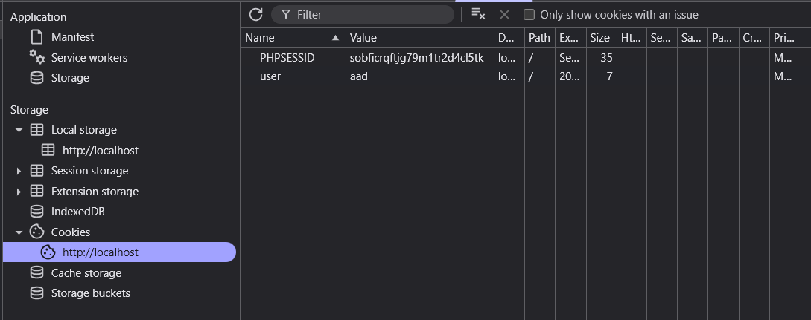

Post Lab questions: Answer the following.
- Write the differences between cookies and sessions considering storage, persistence, data accessibility, scope and security as points of comparison.
Ans. Cookies are small text files stored on the client-side (browser), while sessions store data on the server-side. Cookies persist beyond browser closure depending on their expiration settings, whereas sessions typically expire when the browser closes. Cookies are accessible by both client and server, but session data is only accessible server-side. Regarding scope, cookies can be domain-specific or path-specific, while sessions are application-wide. For security, cookies are less secure as they're stored on the client and can be tampered with, though HTTPOnly and Secure flags help; sessions are more secure since data stays on the server with only a session ID stored in cookies.

- How to check if cookies are enabled or not?
Ans. Code:
<script>
function checkCookiesEnabled() {
document.cookie = "testcookie=1";
var cookieEnabled = document.cookie.indexOf("testcookie") != -1;
document.getElementById("cookieStatus").innerHTML = cookieEnabled ?
"Cookies are enabled" : "Cookies are disabled";
}
</script>
<body onload="checkCookiesEnabled()">
<div id="cookieStatus"></div>
</body>

- How to get all session variable values? Explain with an example code.
Ans.
<?php
session_start();

$_SESSION["username"] = "Om_Thanage";
$_SESSION["user_id"] = 12345;
$_SESSION["is_admin"] = true;

function getAllSessionVariables() {
echo "<h3>All Session Variables:</h3>";
echo "<pre>";
print_r($_SESSION);
echo "</pre>";
}

getAllSessionVariables();
?>

This PHP code starts a session, sets some example variables, and then retrieves and displays all session variables using the built-in $SESSION superglobal array and print_r() function for readable output.

Conclusion: From this experiment we learnt how to use session and cookie and how to use for authentication and for fast data retrieval

